Lesson 1 Social Reform

ESSENTIAL QUESTION
Why do societies change?

GUIDING QUESTIONS
- What was the effect of the Second Great Awakening?
- What type of American literature emerged in the 1820s?
Terms to Know
revival religious meeting
utopia community based on a vision of the perfect society
temperance drinking little or no alcohol
normal school state-supported school for training high-school graduates to become teachers
civil disobedience refusing to obey laws considered unjust

Where in the world?
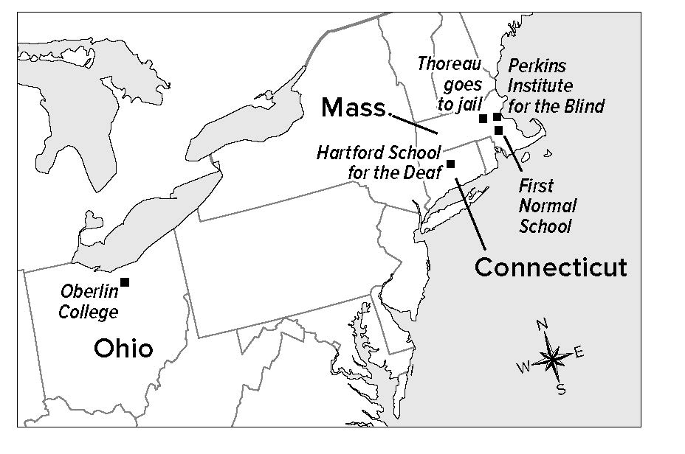

When did it happen?
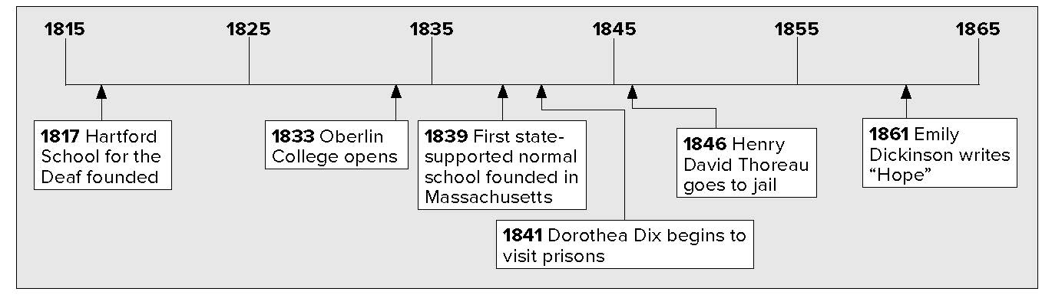

Lesson 1 Social Reform, Continued

Finding the
Main Idea
- Place a checkmark next to the best statement of the main idea of this passage.
Several social reform movements started in the 1800s.
Some reformers worked for temperance.

Evaluating
- Which reformer do you think made the most important contribution to American society?
Why do you think so?

Reading
Check
3. How did Samuel Howe help the visually impaired?

Religion and Reform
Religious meetings, called revivals, were popular in the early 1800s. People traveled far to hear certain preachers. It was a time of great interest in religion. It was known as the Second Great Awakening. The first Great Awakening had been in the mid-1700s.
People thought of ways to reform, or improve, society as a result of attending revival meetings. Some thought that they should set up utopias (yu• TOH• pee• uhs). These were communities based on their idea of a perfect society. Most utopias did not last. One of the groups that did last, however, was the Mormons.
Several social reform movements came about in the 1800s. Some reformers called for temperance. Lyman Beecher was one such reformer. Temperance means to drink little or no alcohol. Reformers used lectures and booklets to warn people about the dangers of drinking alcohol. Some laws were passed to prevent people from drinking. Most of the laws were later repealed, or canceled.
Reformers wanted to fix some problems with education.
- Many teachers were not well-trained.
- Many people did not believe children had to go to school.
- Girls were often kept from going to school.
- Many schools refused to allow African American students to attend.
Horace Mann was a lawyer in Massachusetts. He believed education was the key to getting ahead. Thanks to his work, in 1839, Massachusetts founded the nation’s first state-supported normal school. This was a school in which people were trained to be teachers.
Many colleges and universities started during this time. Most of them only accepted students who were white and male. A few colleges accepted students who were female or who were African American.
Some reforms helped people with disabilities. Thomas Gallaudet (GA• luh • DEHT) created a way to teach people who could not hear. Samuel Gridley Howe helped teach people who could not see. He made books with large raised letters. People could “read” the books with their fingers. Dorothea Dix told people about the bad conditions in prisons.

Lesson 1 Social Reform, Continued

Person | Contributions
Lyman Beecher | tried to prevent drinking of alcohol
Horace Mann | started first state-supported teacher’s college
Thomas Gallaudet | developed a way to teach the deaf
Dorothea Dix | made people aware of bad conditions in prisons

Identifying
4. Identify the person described in each of the following:
A transcendentalist who supported women’s rights in her writings
An American poet who
wrote story poems
Drawing
Conclusions
5. How did art in the United States change in the 1800s?
Reading
Check
6. How did the spirit of reform influence American authors?

Culture Changes
The changes that were taking place in American society affected art and literature. American artists developed their own style. Their art showed American places and ways of life.
Reform also had an effect on literature. A movement began called Transcendentalism. Its members were called transcendentalists. These thinkers and writers showed more of a connection between people and nature. They wrote that a person’s conscience, or sense of right and wrong, was important.
Margaret Fuller wrote about women’s rights. Ralph Waldo Emerson was also a writer in that movement. He wanted people to think about right and wrong. He wanted people to treat others fairly.
Henry David Thoreau practiced a form of protest called civil disobedience (dihs • uh • BEE • dee • uhns). He would not obey laws he thought were unjust. He went to jail because of this belief. In 1846, he would not pay a tax that supported the Mexican War.
American poets created great works. Henry Wadsworth Longfellow wrote poems that told a story. One of his well-known poems is the Song of Hiawatha. In Leaves of Grass, a poet named Walt Whitman tried to show the feelings and spirit of America. The poet Emily Dickinson wrote hundreds of poems .They were mostly about her personal feelings. Many of her poems are about nature.
American artists were developing a purely American style.
They showed American life and landscapes. One group of painters was called the Hudson River School. They painted scenes of the Hudson River Valley in New York. Two well-known artists were Currier and Ives. They made prints of Americans celebrating holidays or enjoying themselves in other ways.

Lesson 1 Social Reform, Continued

7. Place a one-tab Foldable along the dotted line to cover Check for
Understanding. Write Reform and Change on the anchor tab.
Create a memory map by writing the title American Society in the middle of the Foldable tab. Draw five arrows around the title and write words or phrases that explain how society changed due to reforms during the 1800s. Use the Foldable to help complete Check for Understanding.

Fuller: supported women’s rights
Longfellow: wrote story poems
Emerson:
wrote about the importance of conscience
Whitman:
wrote about the new American spirit
Thoreau: practiced civil disobedience
Transcendentalist Thinkers
- humans and nature
- importance of individual conscience
Dickinson: wrote personal poems

Glue Foldable here
Check for Understanding
List four areas of reform in the 1800s.

List three transcendentalists.

