Lesson 3 Secession and War

ESSENTIAL QUESTION
Why does conflict develop?
GUIDING QUESTIONS
1.

2.
What was the importance of the election
of 1860?
What did the attack on Fort Sumter signify?

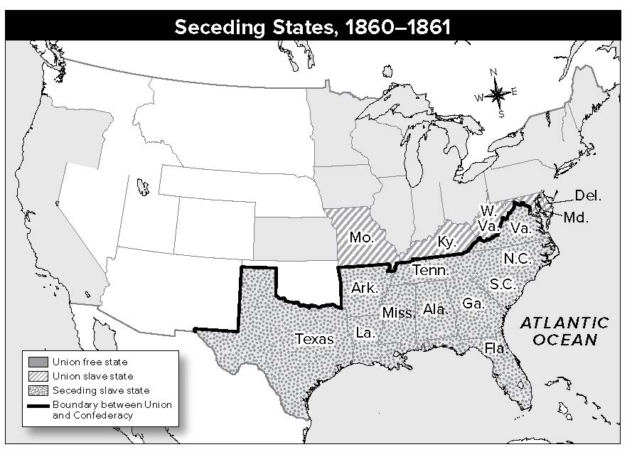
Where in the world?

Terms to Know
secession withdrawal
states’ rights idea that states have the right to control their own affairs, and the federal government does not

When did it happen?
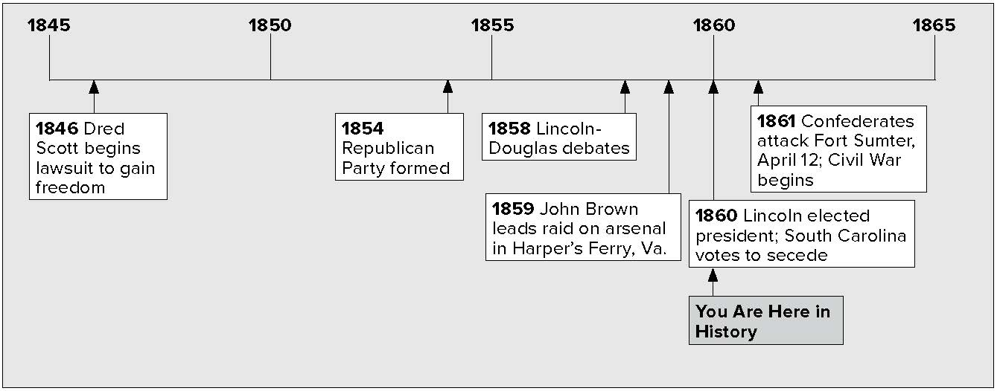

Lesson 3 Secession and War, Continued

The 1860 Election

Identifying
1. Name the 1860 political parties and their candidates for president.

Mark
the Text
2. Underline the name of the first state to secede from the Union.
Visualize It
3. Based on the circle graph, who won most of the electoral votes in 1860?
Reading
Check
4. What was John Crittenden’s suggestion to save the Union?
The issue of slavery split the Democratic Party in the presidential election of 1860.
- Democrats in the North supported popular sovereignty. They chose Stephen A. Douglas as their candidate.
- Democrats in the South favored slavery. They chose John Breckinridge.
- Moderates in the North and South started the Constitutional Union Party. They chose John Bell. The party took no position on slavery.
- Republicans chose Abraham Lincoln. They wanted to leave slavery where it existed, but ban it in the territories. Lincoln’s name was not even on the ballot in most Southern states.
Lincoln won. He won every Northern state. Many Southerners believed the Republicans would try to end slavery wherever it existed. On December 20, 1860, South Carolina left the Union. Other Southern states debated secession, or withdrawing from the Union, too.

1860 Presidential Election
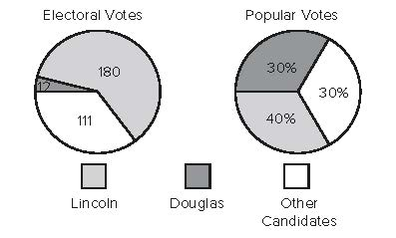

Congress worked to hold the Union together. Senator John Crittenden suggested amendments to the Constitution. He said they would protect slavery south of the line set by the Missouri Compromise. Neither Republicans nor Southern leaders liked Crittenden’s plan.
By February 1861, Texas, Louisiana, Mississippi, Alabama, Florida, and Georgia had seceded. Delegates from these states met with South Carolina leaders. Together they formed the Confederate States of America. They chose Jefferson Davis as their president.

Lesson 3 Secession and War, Continued

Glue Foldable here

5. Place a one-tab
Foldable along the dotted line to cover “Southerners used the idea of states’ rights
. . .” Write Secession on the anchor tab. Write State’s Rights in the middle of the tab.
Draw three arrows around the title and write three things about secession and states’ rights.
Summarizing
6. Describe in your own
words the idea of
states’ rights.
Reading
Check
7. Why do you think Lincoln decided not to send armed troops to Fort Sumter?
Southerners used the idea of states’ rights to explain their decision to secede. They argued that:
  - each state had joined the Union voluntarily.
  - the Constitution was a contract between the federal government and the states.
  - the government broke the contract because it did not give Southern states equal rights in the territories.
  - therefore, a state had the right to leave the Union.
Not all Southerners believed in secession. Some Northerners were glad to see Southern states leave the Union. Most Northerners, however, thought secession would be bad for the country.
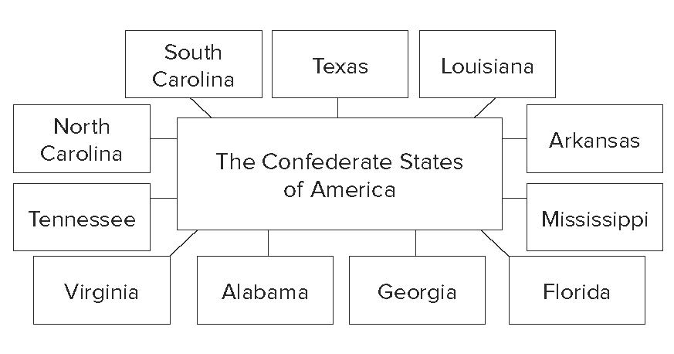

In March 1861, Abraham Lincoln took office as president.
He asked the seceding states to rejoin the Union. He pleaded for peace. He also warned that he would enforce federal law in the South.

Fighting at Fort Sumter
The day after Lincoln took office, he received a message. It came from Fort Sumter, a U.S. fort on an island in Charlston Harbor, South Carolina. The fort’s commander warned that supplies were low. He said the Confederates were demanding that he surrender. Lincoln sent an unarmed group with supplies. He ordered Union troops at the fort not to fire unless they were fired upon.
Jefferson Davis made a historic choice. He ordered Confederate troops to attack Fort Sumter before the supplies arrived. On April 12, 1861, the Confederates fired on Fort Sumter.

Lesson 3 Secession and War, Continued

Rough, high seas kept Union ships from coming to help. Two days later, Fort Sumter surrendered. The Civil War had begun.

8. Place a two-tab Foldable along the dotted line to cover Check for
Understanding. Cut the tabs in half to form four tabs. Write Jefferson Davis on the anchor tab. Label the tabs who, what, when, and where. List what you remember about Jefferson Davis as you answer each question. Use the Foldable to help answer Check for Understanding.
Lincoln issued a call for troops. Volunteers quickly signed up. Meanwhile, Virginia, North Carolina, Tennessee, and Arkansas joined the Confederacy.

Glue Foldable here

Check for Understanding
Write the name of the new nation formed by the states that seceded and its president.

What was the historic choice Jefferson Davis made, and why was it historic?
The historic choice was

Davis’s choice was historic because

