Lesson 2 Challenges to Slavery

ESSENTIAL QUESTION
Why does conflict develop?

GUIDING QUESTIONS
- How did a new political party affect the challenges to slavery?
- Why was the Dred Scott case important?
- How did Abraham Lincoln and Stephen A. Douglas play a role in the challenges to slavery?
Terms to Know
arsenal a place to store weapons
martyr a person who dies for a cause

Where in the world?
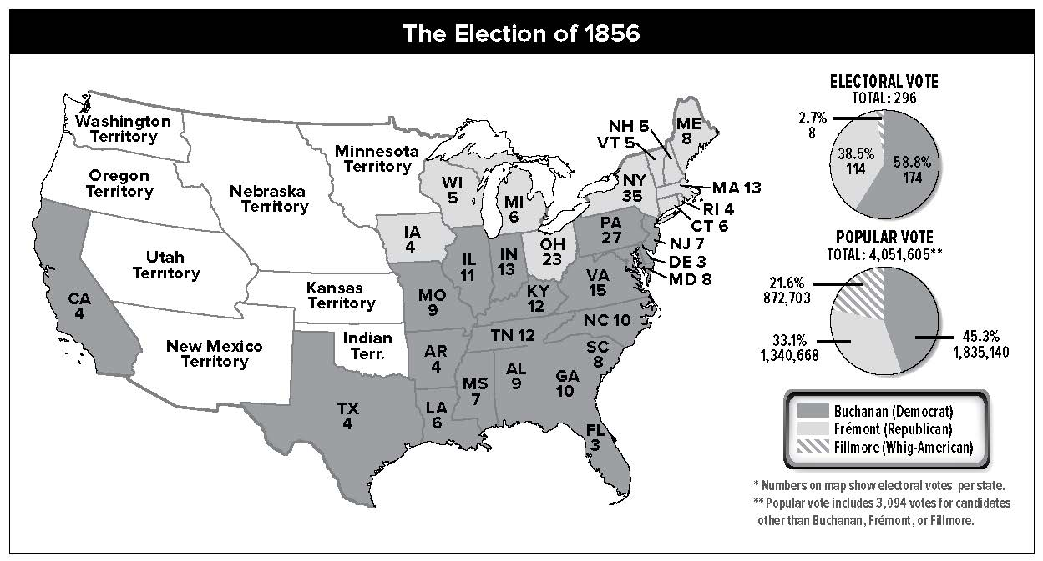

When did it happen?
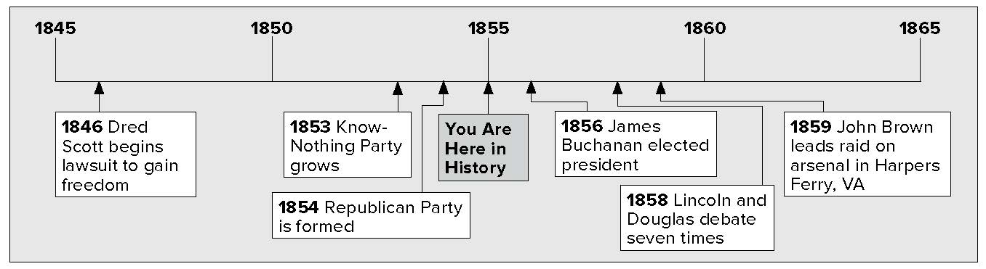

Lesson 2 Challenges to Slavery, Continued

Birth of the Republican Party
The Kansas-Nebraska Act drove the North and South further apart. Many Northern Democrats left the party. In 1854, antislavery Whigs and Democrats joined with Free-Soilers. They started the Republican Party. They wanted to ban slavery in new territories. Northerners liked the Republican Party’s message. The Republicans won seats in Congress. The Democratic Party became mostly a Southern party.

Reading
Check
1. Who joined together to form the Republican Party? What was their goal?
Visualize It
2. Who was the “Know- Nothing” Party’s candidate? How much of the popular vote did he receive? How many electoral votes did he get?
Sequencing
3. Number these events in the order in which they happened.
The doctor moves with Dred Scott to Illinois and then to the Wisconsin territory.
The doctor and Dred Scott return to Missouri.
___ A doctor buys Dred Scott in Missouri.
In the presidential election of 1856:
- the Republicans chose John C. Frémont as their candidate. The party called for free territories.
- the Democrats nominated James Buchanan. The party wanted popular sovereignty, or government where the people are the authority.
- the American Party, or “Know-Nothings,” nominated former president Millard Fillmore.
- the Whigs were very divided over slavery. They did not have a candidate.
Buchanan won the most electoral votes. He won all the Southern states except Maryland. None of Frémont’s electoral votes came from south of the Mason-Dixon line.

Candidate | Popular Vote | Electoral Vote
Buchanan | 1,838,169 | 174
(Democrat) | (45%) | (59%)
Frémont | 1,341,264 | 114
(Republican) | (33%) | (38%)
Fillmore | 874,534 | 8
(“Know-Nothing”) | (22%) | (3%)

Dred Scott v. Sandford
Dred Scott was an enslaved African American. A doctor in Missouri, a slave state, bought him. In the 1830s, the doctor and Scott moved to Illinois. Illinois was a free state. Then they moved to the Wisconsin Territory. Slavery was not allowed there. Later the doctor and Scott returned to Missouri.
In 1846, Dred Scott went to court to get his freedom. He said he should be free. He said this because he had lived where slavery was not allowed.

Lesson 2 Challenges to Slavery, Continued

The case finally came before the Supreme Court in 1857. The case gained a lot of attention. It gave the Court a chance to rule on the question of slavery itself. Justice Roger B. Taney was the head of the Supreme Court. He wrote the Court’s decision.

Explaining
4. Why did Dred Scott think he should be free?
Reading
Check
5. In the Dred Scott decision, why could voters or Congress not ban slavery?
Mark
the Text
6. Underline the sentence(s) that tells what people liked about Lincoln.
This is what the Supreme Court decided:
  - The fact that Scott had lived in areas where slavery was not allowed did not make Scott a free man.
  - Dred Scott was not a citizen. Because of this he had no right to go to court.
  - Enslaved people were property.
  - The Missouri Compromise was not allowed, according to the United States Constitution.
  - Popular sovereignty was not allowed, according to the United States Constitution.
  - Neither Congress nor voters could ban slavery. That would be like taking away a person’s property.
The Court’s decision angered Northerners. Southerners believed that now nothing could stop the spread of slavery.

Lincoln and Douglas
In 1858 the Illinois Senate race was the center of attention throughout the country, because of the candidates. Senator Stephen A. Douglas, a Democrat, was running against Abraham Lincoln, a Republican.
Douglas was popular. People thought he might run for president in 1860. Lincoln was not as well known. He challenged Douglas to debate him. A debate is a kind of argument. There are rules for how to state your point.
Lincoln and Douglas debated seven times. Slavery was the main topic each time. All the debates were in Illinois. Thousands of people came to watch. Many newspapers wrote articles about the debates.
Douglas supported popular sovereignty. He believed people could vote to limit slavery. People in the South did not like him after that. Lincoln said that African Americans had rights. He said that slavery was wrong.
Douglas won the election. Even though he lost, Lincoln became popular around the nation. People thought of him as a clear thinker who could state his ideas well.
Southerners felt threatened by Republicans. In 1859 an act of violence added to their fears. Abolitionist John Brown led a raid

Lesson 2 Challenges to Slavery, Continued

on Harpers Ferry, Virginia. The target was an arsenal

Reading
Check
7. Why did John Brown raid the arsenal at Harpers Ferry?

8. Place a Venn diagram
Foldable along the dotted line to cover Check for
Understanding. Write the title Opposed to Slavery on the anchor tab. Label the three tabs Republican Party, Both, and Dred Scott. Write two things you remember about each and one thing they have in common. Use the Foldable to help answer Check for Understanding.
(AHRS • nuhl), a place where weapons are stored. Brown hoped to arm enslaved African Americans. He hoped they would revolt against slaveholders.
Local citizens and troops stopped the raid. Brown was convicted of treason and murder. He was hanged. His death divided the North. Some antislavery groups had never approved of Brown’s violence. Others saw him as a martyr—a person who dies for a great cause.

Glue Foldable here

Check for Understanding
Name the three anti-slavery parties from which people came to start the Republican Party.

List two of the reasons the Supreme Court gave for its decision in the Dred Scott case.

