Lesson 1 The Search for Compromise

ESSENTIAL QUESTION
Why does conflict develop?
GUIDING QUESTIONS
1. What political compromises were made because of slavery?
2. What is the Kansas-Nebraska Act?
Terms to Know
fugitive person who runs away from the law
secede leave
border ruffian armed pro-slavery supporter who crossed the border from Missouri to vote in Kansas
civil war fighting between citizens of the same
country

Where in the world?
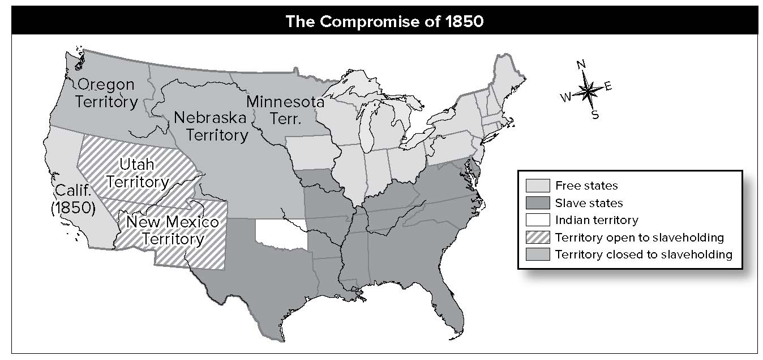

When did it happen?
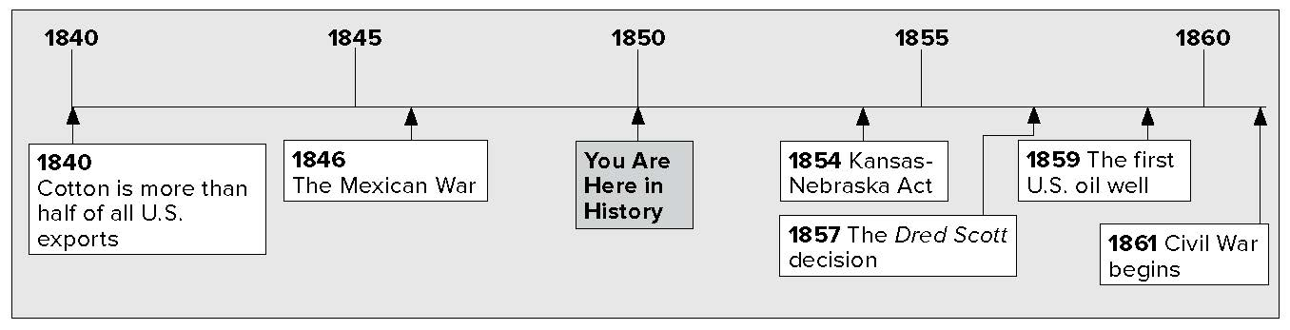

Lesson 1 The Search for Compromise, Continued

Political Conflict Over Slavery
Drawing
Conclusions
- What conclusion
can you draw about who won the Mexican War?
Mark
the Text
2. Underline the name of the plan that would ban slavery from any lands taken from Mexico.

Reading
Check
3. Who formed the Free Soil Party and why?
The question of slavery divided Americans. Many Northerners wanted to ban it. Most Southerners wanted Northerners to stay out of the South’s business. Each time there was a debate over slavery, the nation’s leaders came up with a compromise. For example, Congress passed the Missouri Compromise in 1820. This kept a balance of power in the Senate between slave states and free states. It also stopped the debate over slavery for a little while.
In the 1840s there was another disagreement over slavery in new territories. Texas became a state in 1845. This angered Mexico. The United States and Mexico fought over the boundary between Texas and Mexico. A war with Mexico followed. After the Mexican War, the United States took New Mexico and California.
Representative David Wilmot of Pennsylvania wanted slavery banned in any lands gotten from Mexico. His plan was called the Wilmot Proviso. Southerners did not like this plan. They wanted California and New Mexico open to slavery. Senator John C. Calhoun stated that Congress could not ban or control slavery in any territory.
In 1848 both presidential candidates ignored the slavery issue. This made voters angry. Many antislavery Whigs and Democrats formed the Free-Soil Party. The new party’s slogan was “Free Soil, Free Speech, Free Labor, and Free Men.” Former president Martin Van Buren was the party’s candidate. He lost the election and Zachary Taylor won. Still, the party gained some seats in Congress.
The debate over slavery came up again in 1849 because:
- California wanted to become a state as a free state;
- antislavery groups wantesssd to ban slavery in Washington, D.C.;
- Southerners wanted a stronger fugitive, or runaway slave, law. All states would have to return runaway slaves.
If California entered the United States as a free state, slave states would be outvoted in the Senate. Southerners talked about seceding from, or leaving, the Union.
Senator Henry Clay tried to find a compromise. He suggested that:
- California be a free state.
- slavery would be allowed in new territories.

Lesson 1 The Search for Compromise, Continued
Critical
Thinking
4. How do you think Clay’s proposal for Washington, D.C., pleased both the North and the South?
Vocabulary
5. Who were the border ruffians?

  - the slave trade would be illegal in Washington, D.C., but slavery itself would be allowed.
  - there would be a stronger fugitive slave law.
Congress discussed the ideas and argued about them. Senator Stephen A. Douglas of Illinois solved the problem. He divided Clay’s plan into parts. Congress voted on each part separately. In this way, Congress passed five laws. Together, they are called the Compromise of 1850.
Compromise  of 1850 | Major Ideas
Senator Henry Clay had the ideas.  Senator Stephen A. Douglas made the plan.  Five separate laws were passed. | 1. Stronger Fugitive Slave Law  2. California to be a free state  3. Other new territories could have slavery  4. Okay to have slaves in Washington, D.C.  5. However, no slave trade in Washington, D.C.

The Kansas-Nebraska Act
In 1854 Senator Douglas suggested making the lands west of Missouri into two territories. They would be called Kansas and Nebraska. They were north of the line that limited slavery, so the two states would be free states. Douglas knew the South would object. He suggested that Congress repeal the Missouri Compromise. Instead, settlers in those areas would vote on whether to allow slavery. Douglas called this “popular sovereignty.” That means the people are allowed to decide.
Many Northerners did not like Douglas’ plan. It would allow slavery in places that had been free for years. Southerners liked the plan. They thought Kansas would be settled mostly by slaveholders from Missouri. Since slavery was legal in Missouri, those settlers would vote to make slavery legal in Kansas, too.
Pro-slavery and antislavery groups rushed to Kansas Thousands of pro-slavery supporters crossed the border from Missouri just for the purpose of voting in Kansas. They traveled in armed groups. They were known as border ruffians
(BOHR • duhr RUH • fee • uhns).

Lesson 1 The Search for Compromise, Continued
Reading
Check
6. What events led to “Bleeding Kansas”?

7. Place a two-tab Foldable along the dotted line to
cover Check for Understanding. Write the title Slavery on the anchor tab.
Label the tabs pro-slavery and
antislavery. Write two things you remember about each group. Use the Foldable to help answer Check for Understanding.

The Kansas-Nebraska Act passed in 1854. The pro-slavery group had won. Kansas passed laws in favor of slavery. People opposed to slavery refused to accept the laws. Instead, they held their own election. They adopted a constitution that banned slavery. By 1856, Kansas had two separate governments.
Both antislavery and pro-slavery groups had weapons. Soon fighting broke out. Pro-slavery supporters attacked a town where many antislavery supporters lived. Then John Brown, an abolitionist, led an attack on a pro-slavery group. Brown’s group killed five slavery supporters. Newspapers called the conflict “Bleeding Kansas” and the “Civil War in Kansas.” A civil war is a war between people of the same country.

Check for Understanding
Why did Senator Douglas suggest that Congress repeal the Missouri Compromise?

What two groups were involved in a “civil war” in Kansas?

